Goal
By the end of this stage, your X-axis should look like this:
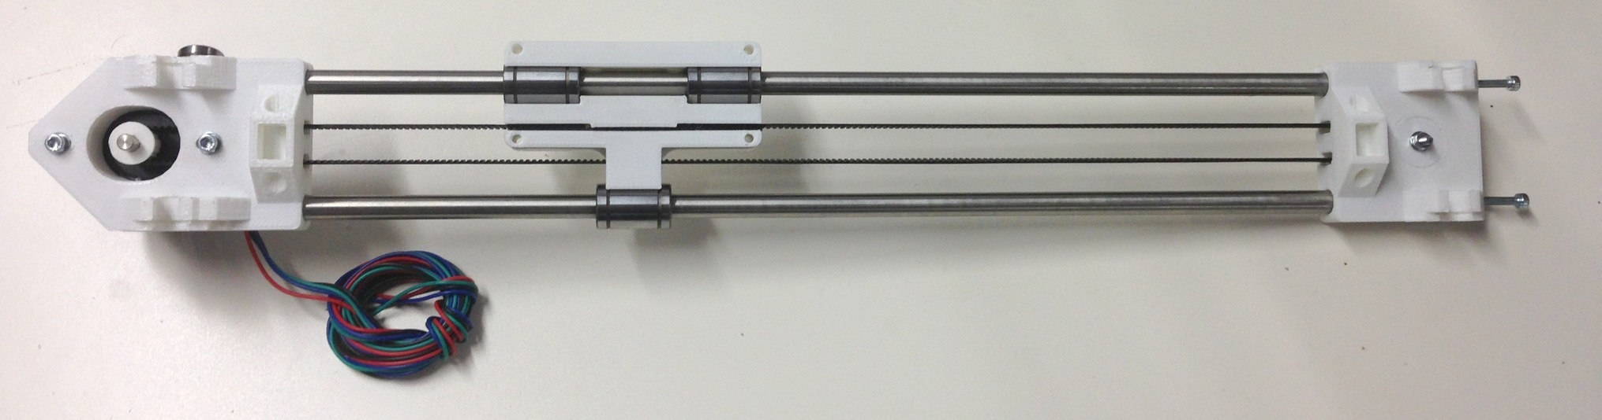

Tools
You will need the following tools
- M3 Allen key
- M3 spanner/nut runner
- Long-nosed pliers

Step 1: Main X Axis Assembly

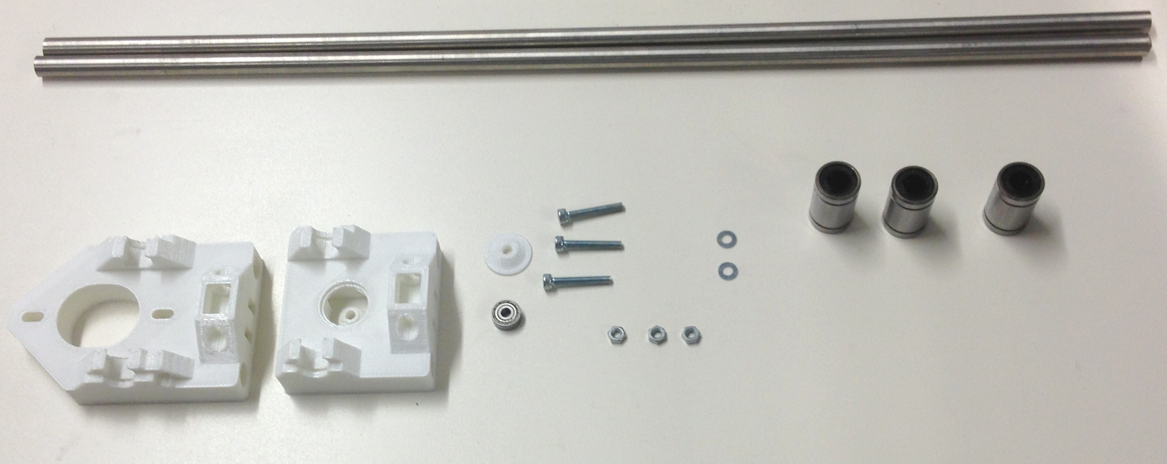
Item | Quantity
428mm Smooth X Rods | 2
Printed X Motor Bracket | 1
Printed X Idler Bracket | 1
Printed X Idler Cover | 1
623 Bearing | 1
M3 washers | 2
M3x20mm cap screws | 3
LM8UU linear bearings | 3
M3 nuts | 3

Begin by assembling the Y Idler Bracket. Take one M3x20 capscrew and a corresponding washer and insert it through the hole in the centre of the part as shown below. Then insert this assembly through the 623 idler bearing, through the cover and secure with a M3 nut and washer.

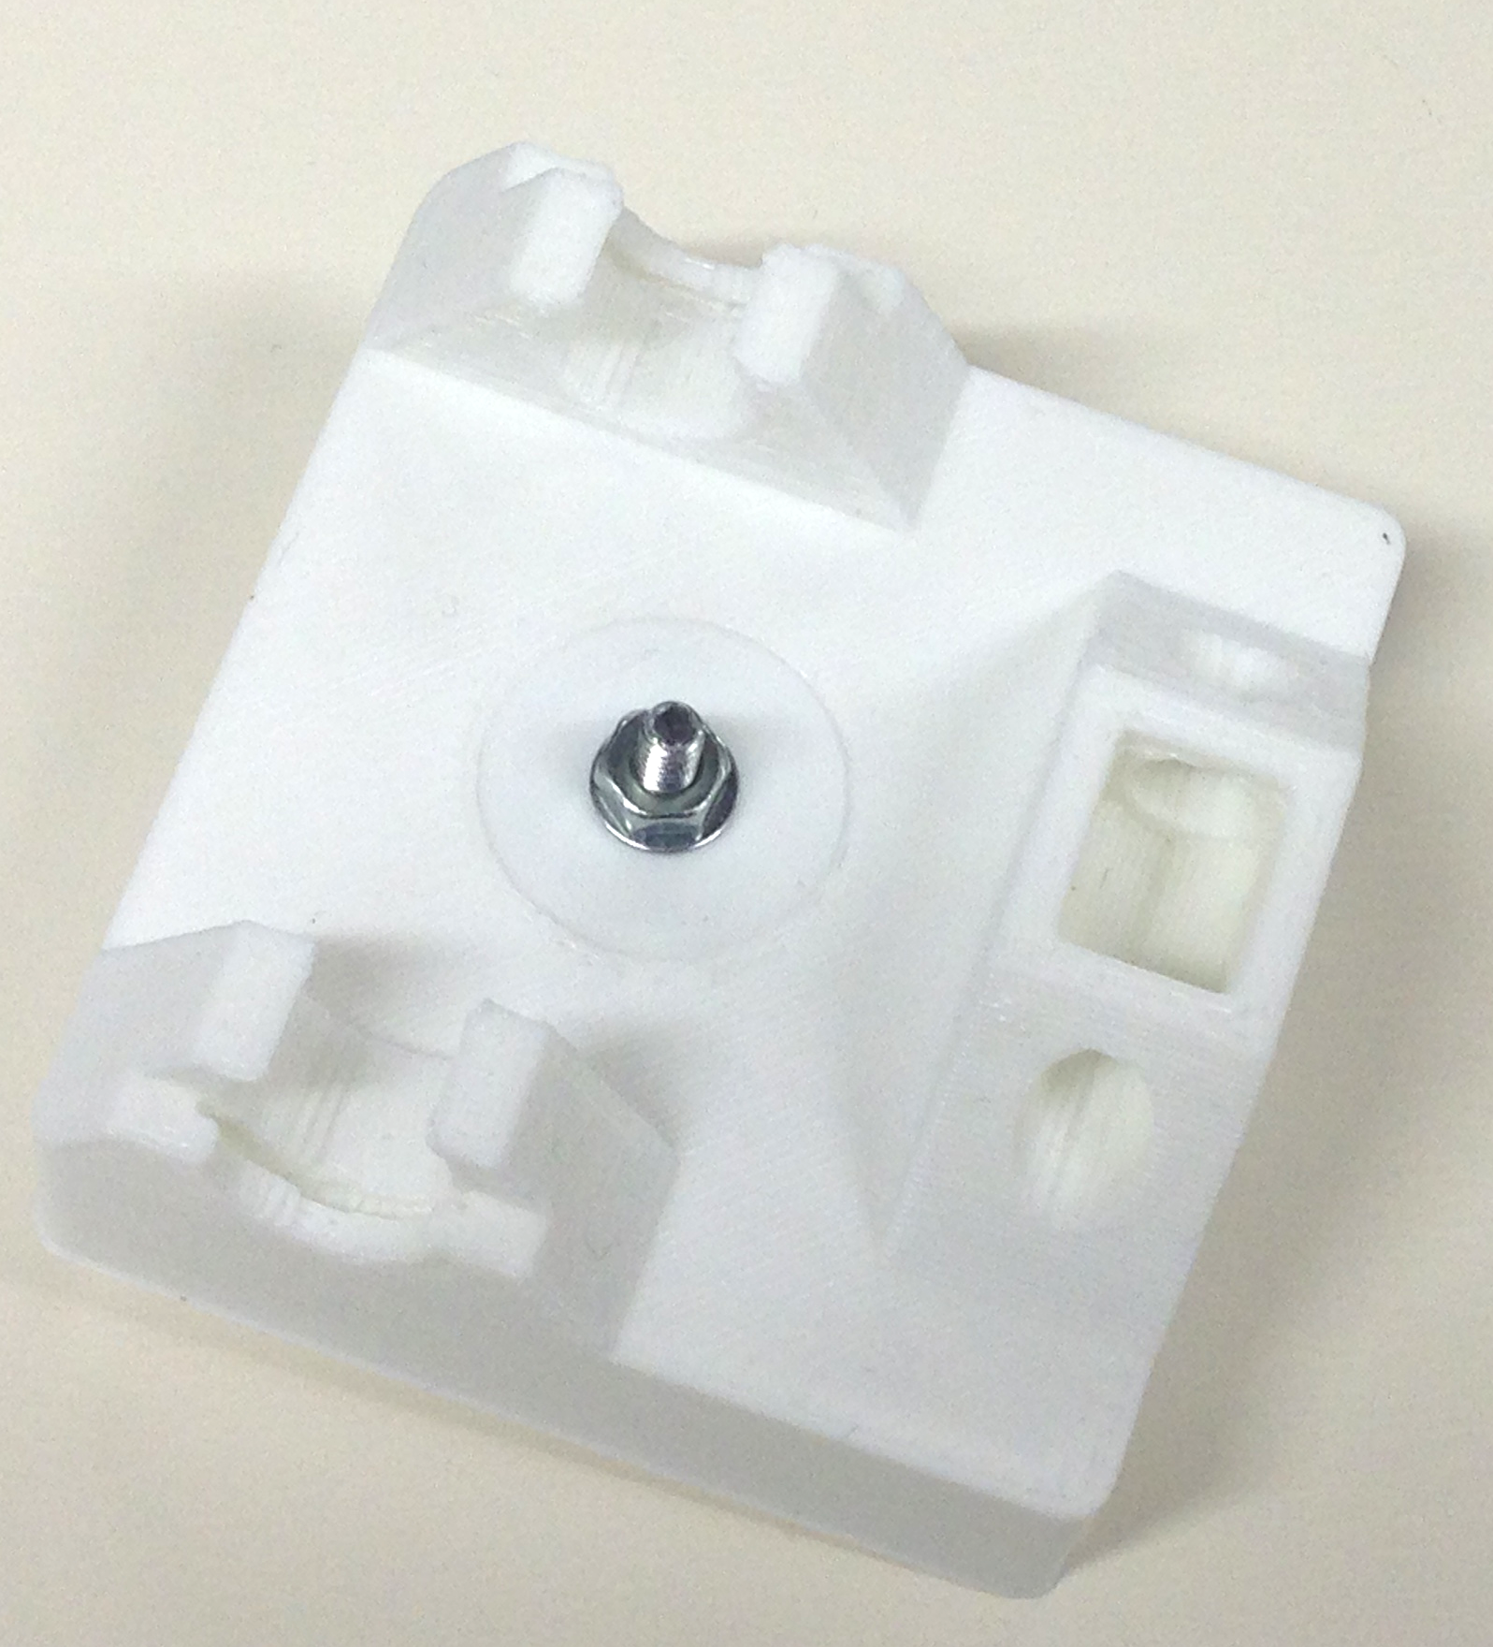
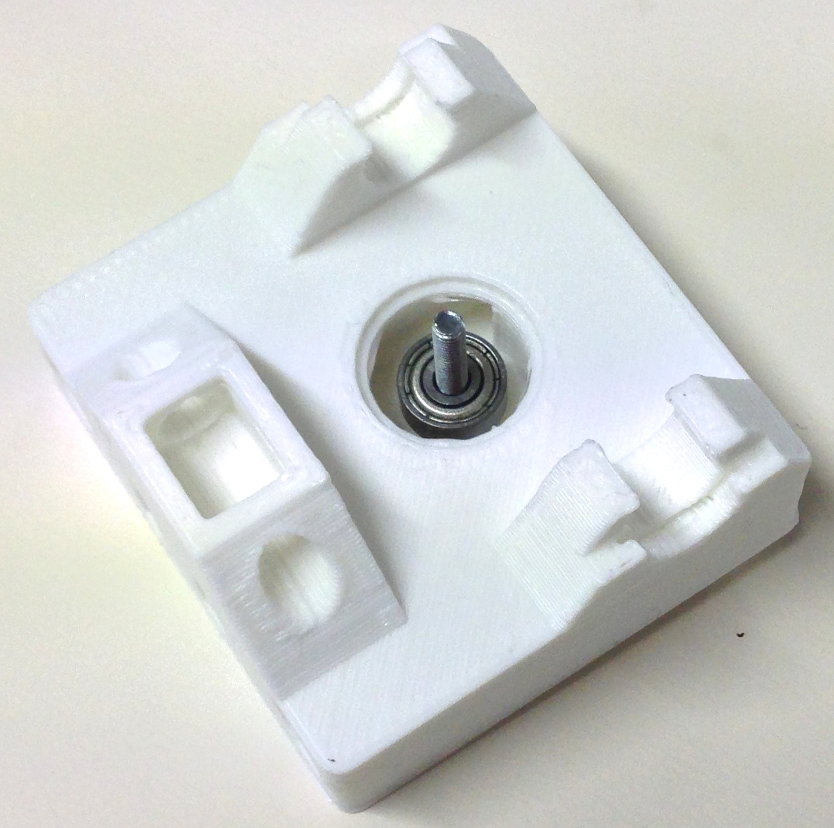
Next insert two M3 washers into the slots on the back of the idler bracket. These are intentionally a tight fit, so you may need to use a long-nosed pliers in order to grip them. The nuts should go in sufficiently far that the holes of the M3 nuts line up with the small holes in the end of the idler. bracket.
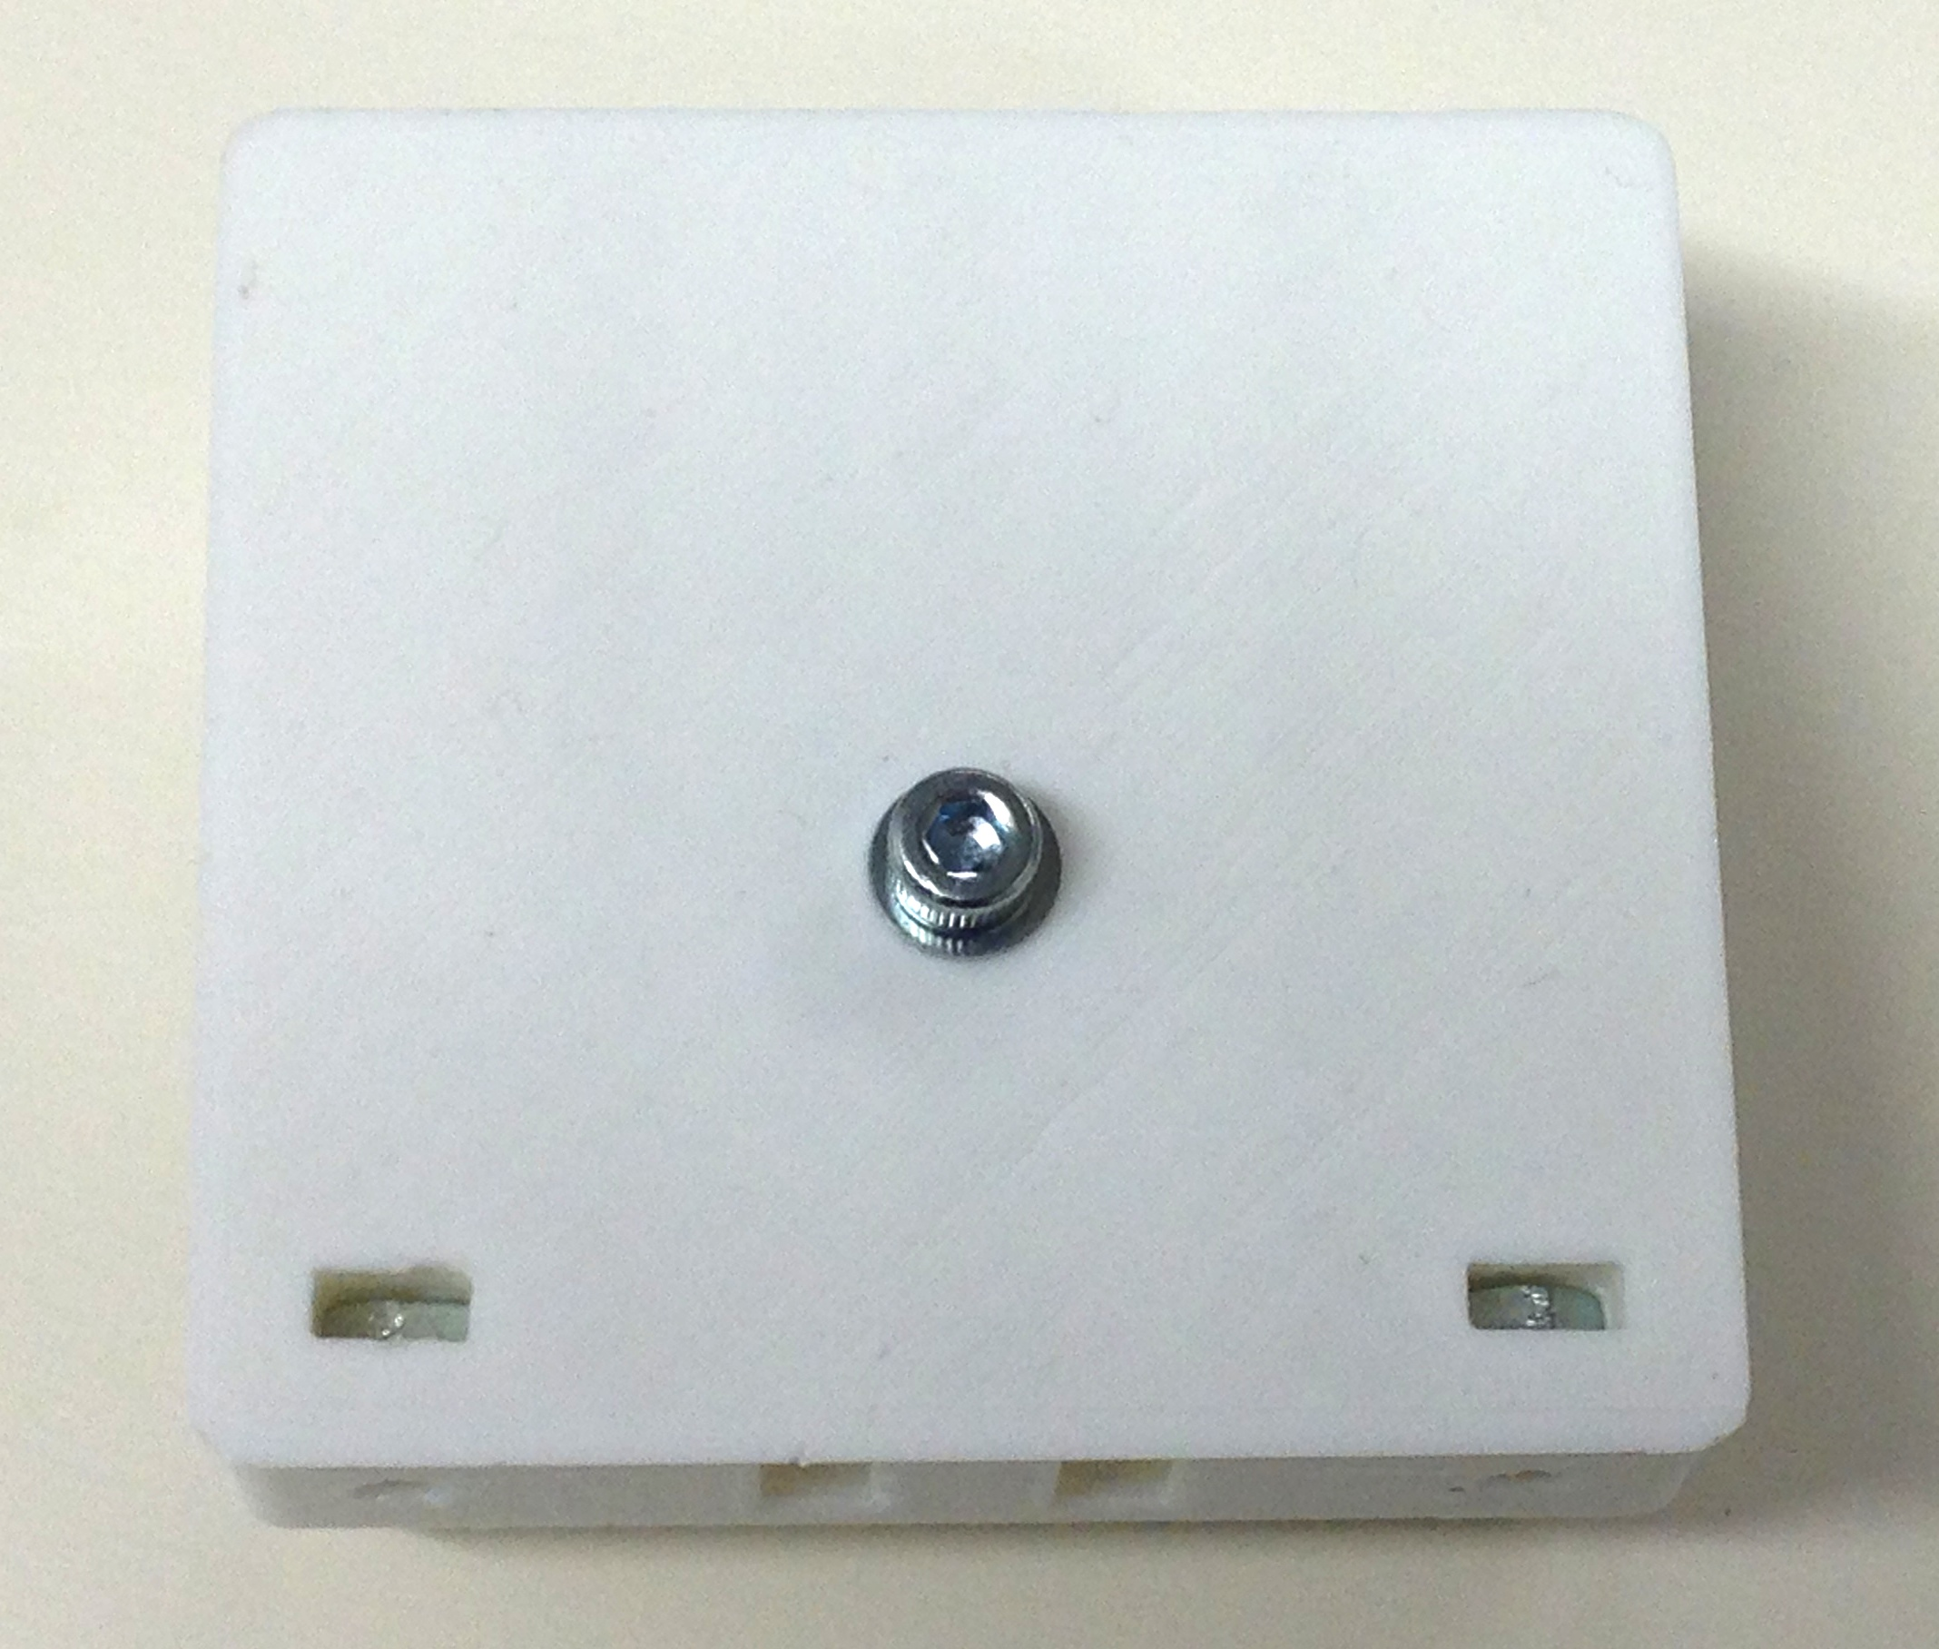
Next begin to assemble the axis. Take the 428mm smooth rods and insert these into the large holes in the end of the X idler bracket. Then proceed to slide the linear bearings onto the smooth rods. Note the orientation of the bearings, when looking at the top/complex side of the idler bracket, two bearings go on the top bar with the one remaining bearing on the bottom bar as shown:
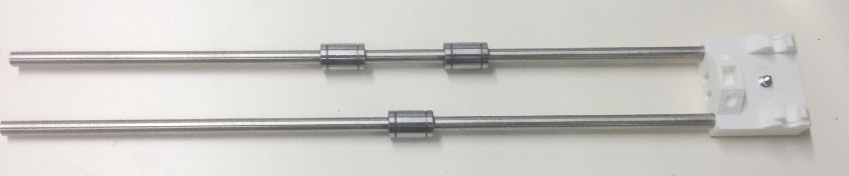
Ensure the rods are completely inserted into the X idler bracket, then insert the free end of the rods into the X motor bracket:

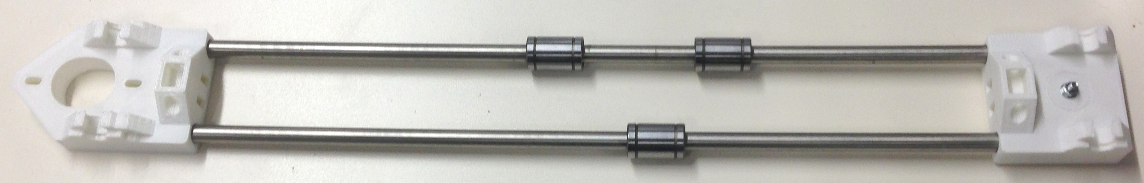

Step 1: X Motor Assembly
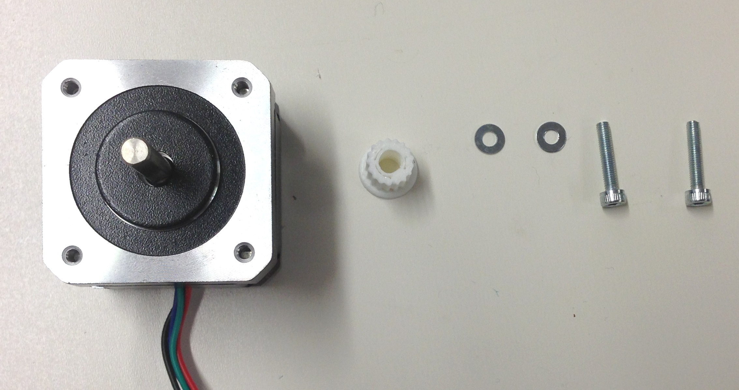
Item | Quantity
Nema 17 Stepper Motor | 1
MXL Printed Pulley | 1
M3 Washer | 2
M3 x 16mm cap screw | 2

Start by inserting the the pulley onto the motor shaft. It should be a tight fit, and you may have to tap it into place. Use a soft hammer, or a wood block. If you place a tube against the pulley that will fit over the motor shaft (or an M8 nut works well), you can tap the end of the tube to place the pulley. Support the motor shaft, not the motor body, from the other end as you tap. You can secure the pulley with a drop of superglue if you like (make sure the shaft is completely free of grease). Take care that no glue gets near the shaft's entry to the motor. Note how both the motor and the pulley has a small flat in the shaft and the hole respectively. These need to be aligned and the flange of the pulley should be facing the end of the motor shaft as shown in the picture below.
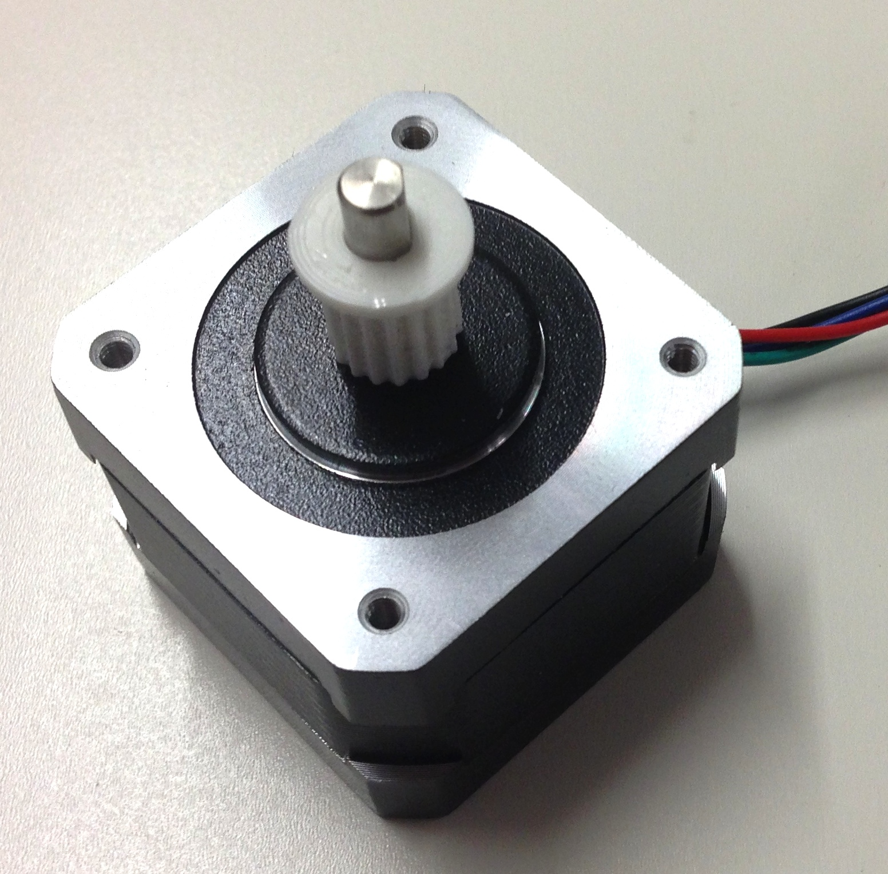

Use the two M3 cap screws and corresponding washers to secure the motor to the X motor bracket as shown below. Note the orientation of the motor wire relative to the bracket.

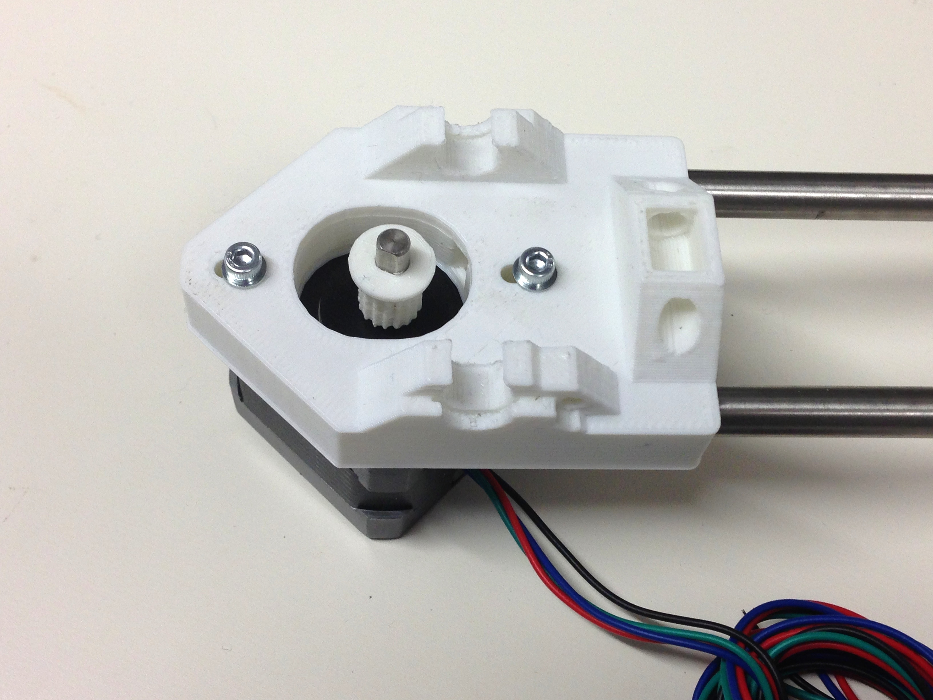

Step 3: Belt and X Carriage
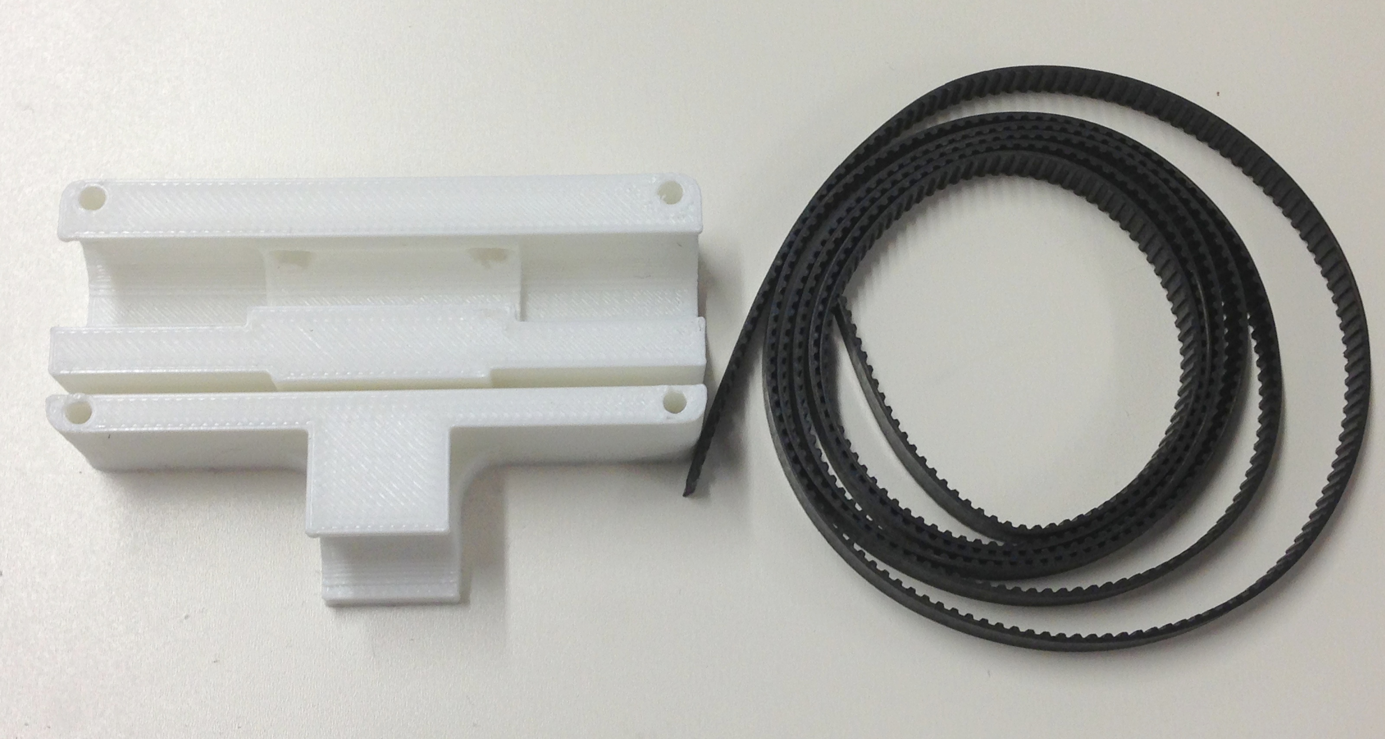
Item | Quantity
X carriage | 1
MXL Timing Belt | Approx
M3 Washer | 2
M3 x 16mm cap screw | 2

Firstly push the linear bearings on the X axis into their slots on the X carriage. THE BEARINGS SHOULD ONLY BE PUSHED IN FROM THE SIDES, PUSHING THEM IN FROM THE FRONT WILL RESULT IN THE X CARRIAGE SNAPPING.

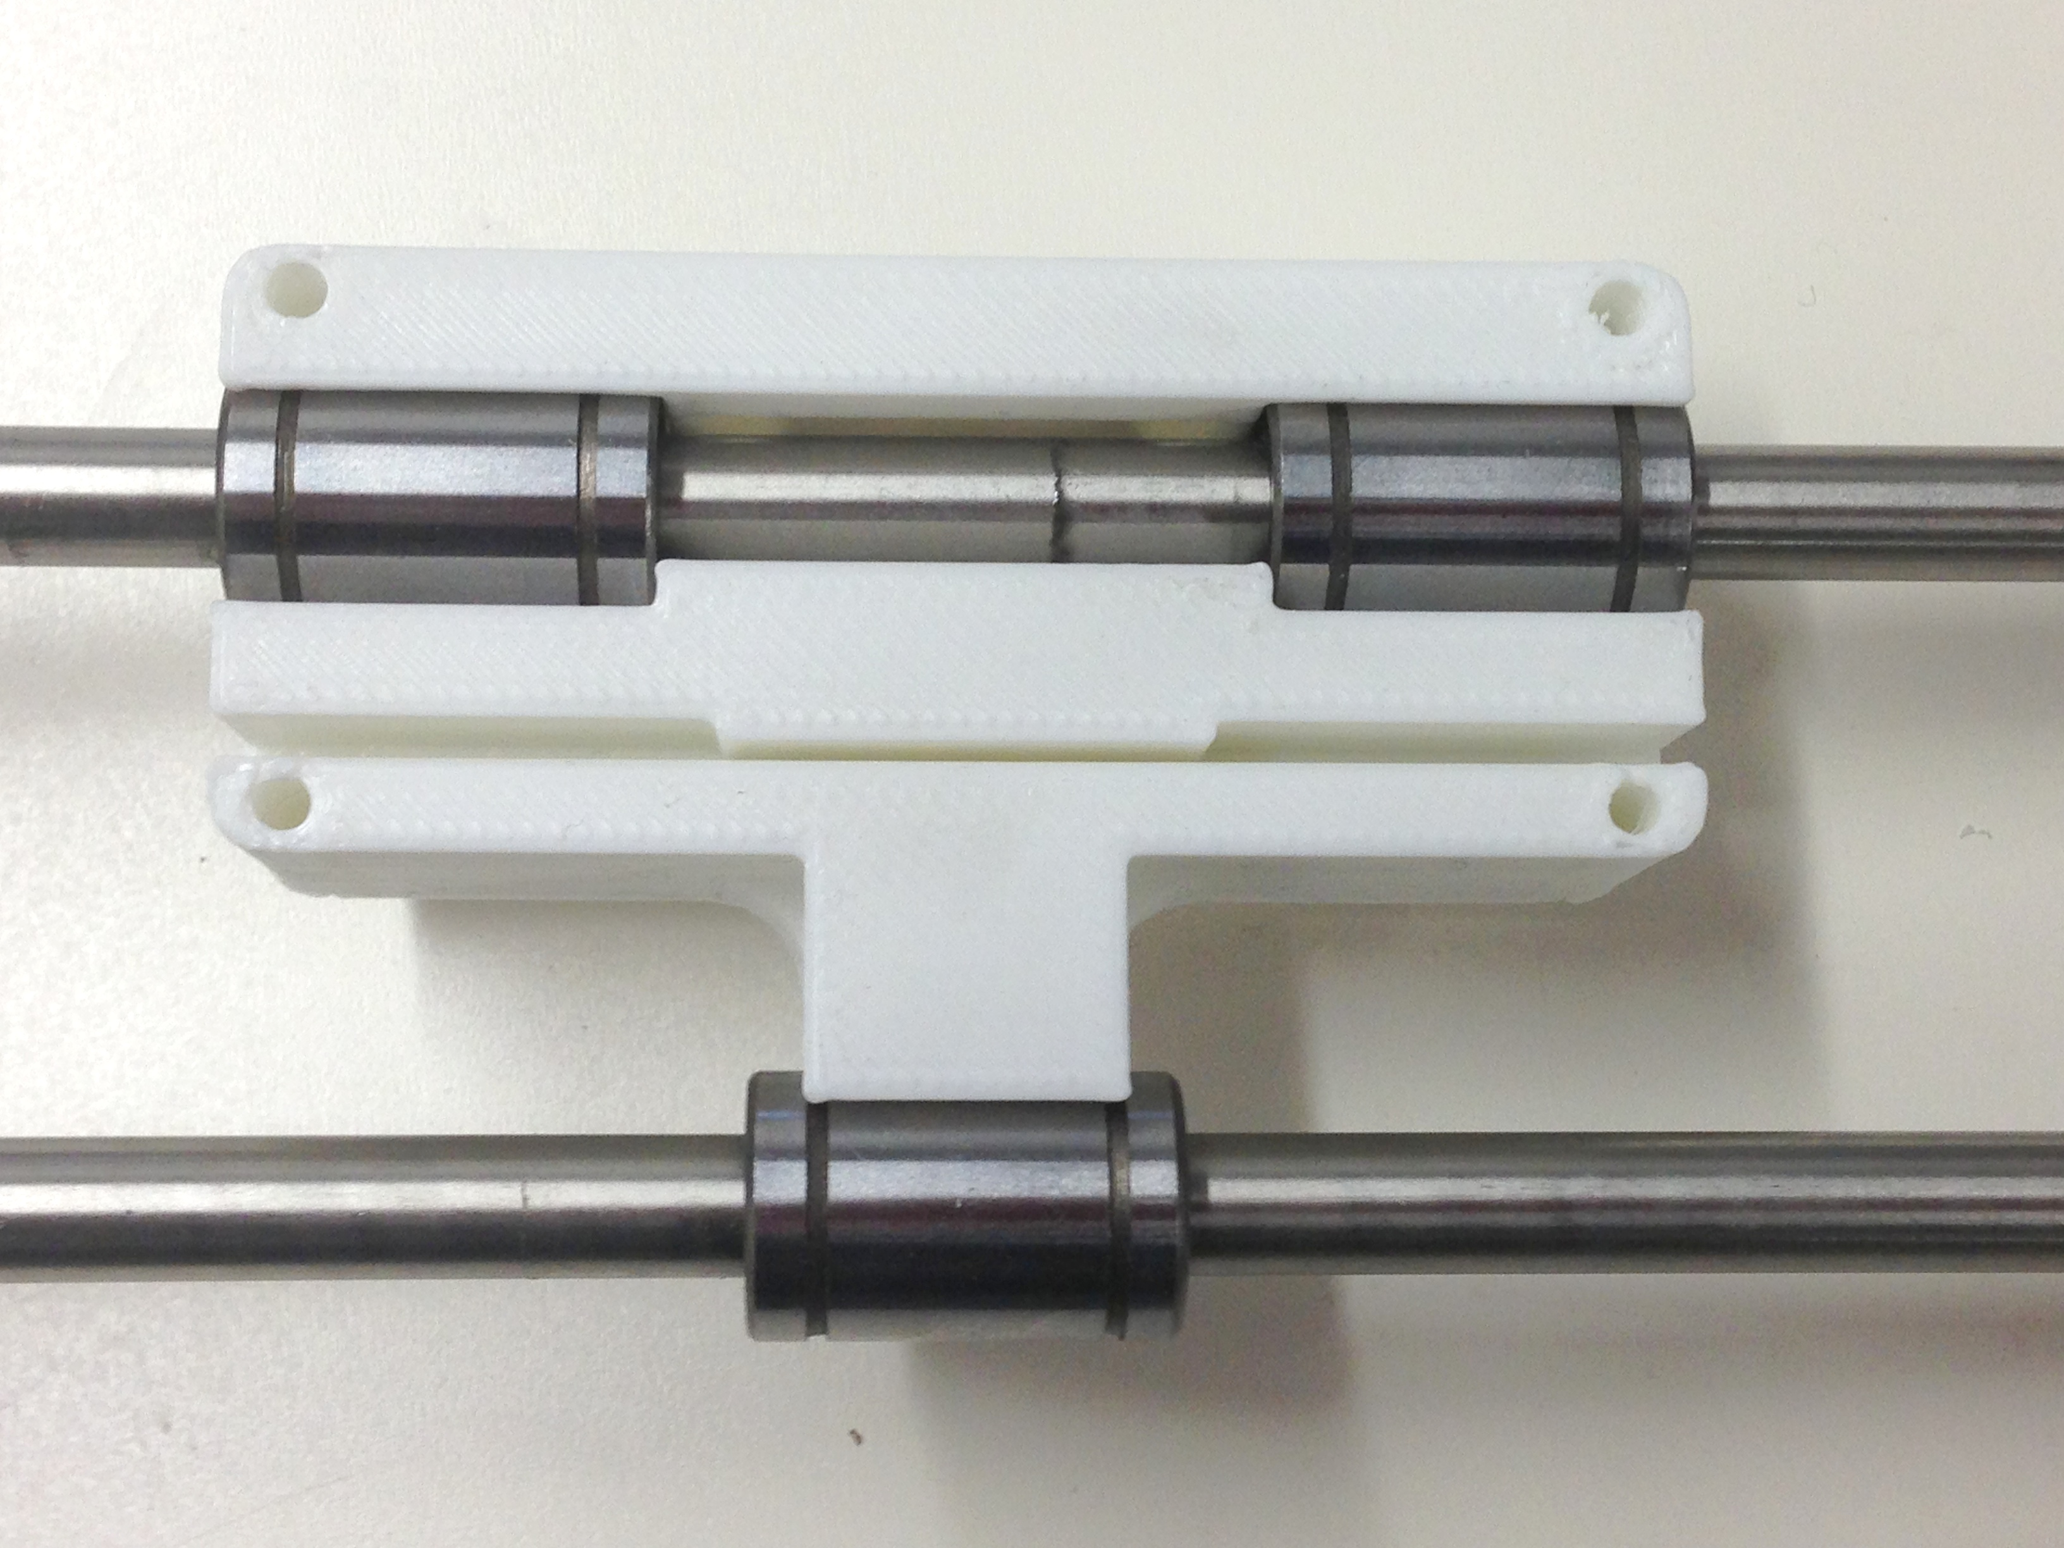

cut off a small length of belt approximately 80mm long (the width of the X carriage), and press this into the slot of the carriage with the teeth facing upwards. This fit is deliberately very tight and you may need to use a small flat head screw driver. The belt should be pushed to the very back of the slot.
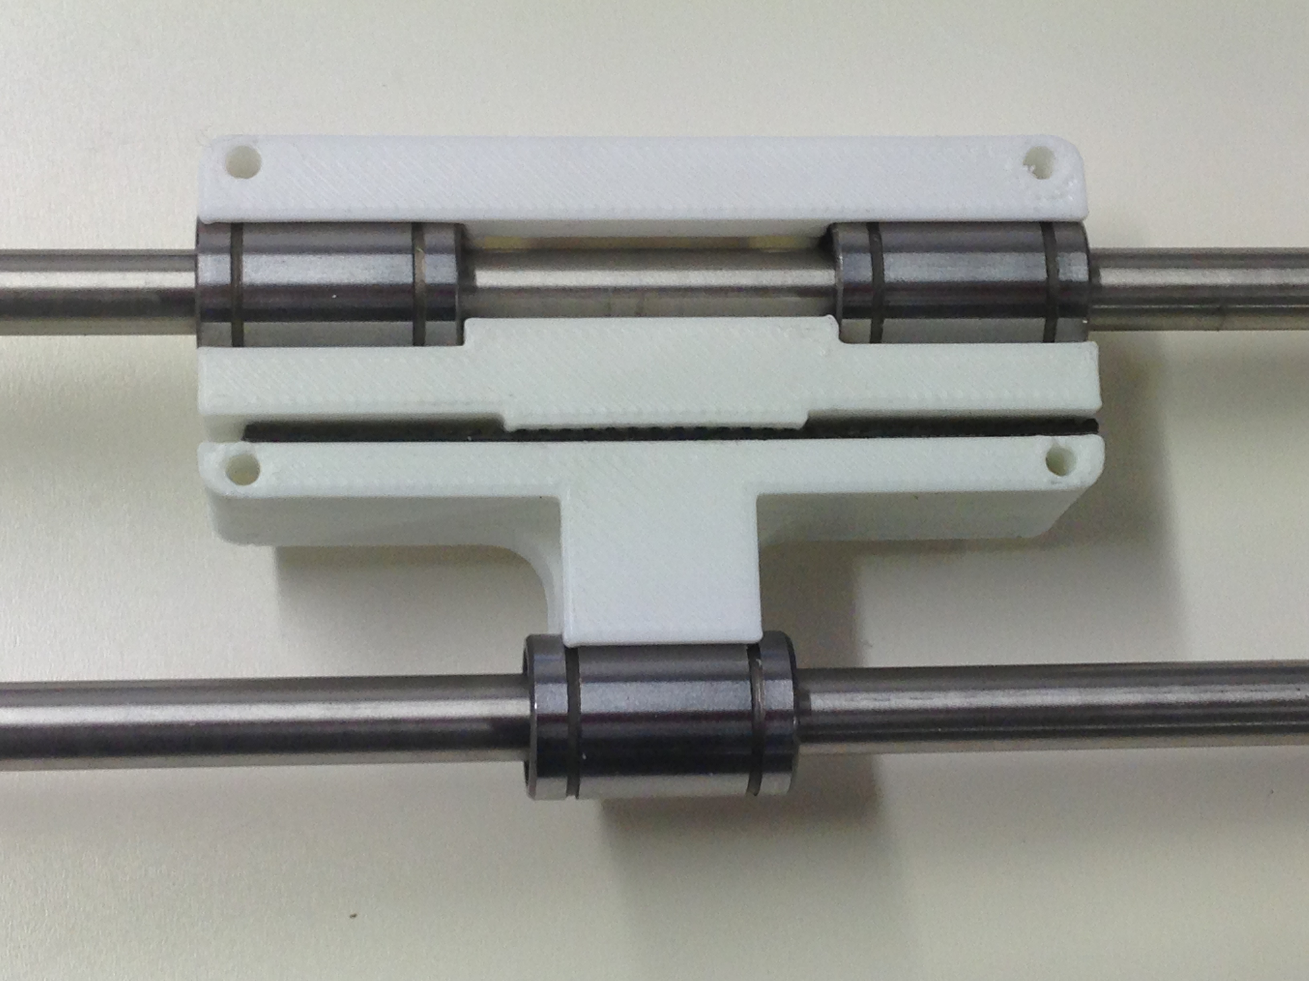

Next take the remaining belt, and insert the free end into the slot in the right end of the X carriage so that it locks with the teeth of the small length of belt. It should ideally be placed as far into the slot as possible so that the end touches the edge of the narrow gap in the centre of the carriage. Then feed the belt through the X end Idler, around the small bearing, back through the carriage, around the motor pulley and back into the slot on the X carriage as shown below

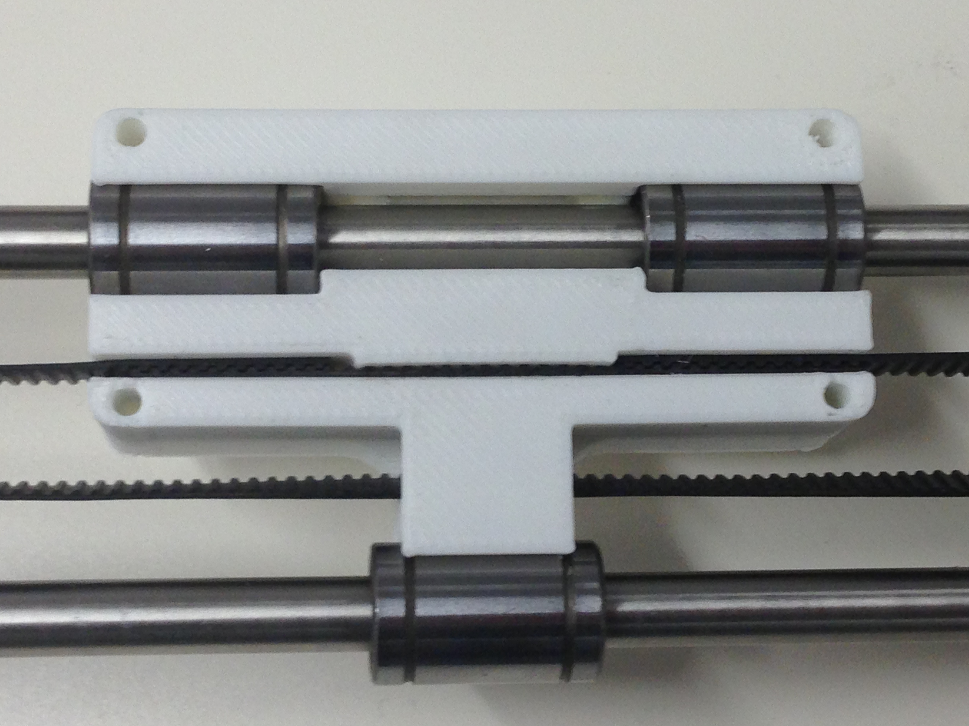
Your X axis mechanicsshould now be complete and look as follows:

Step 3: Endstop
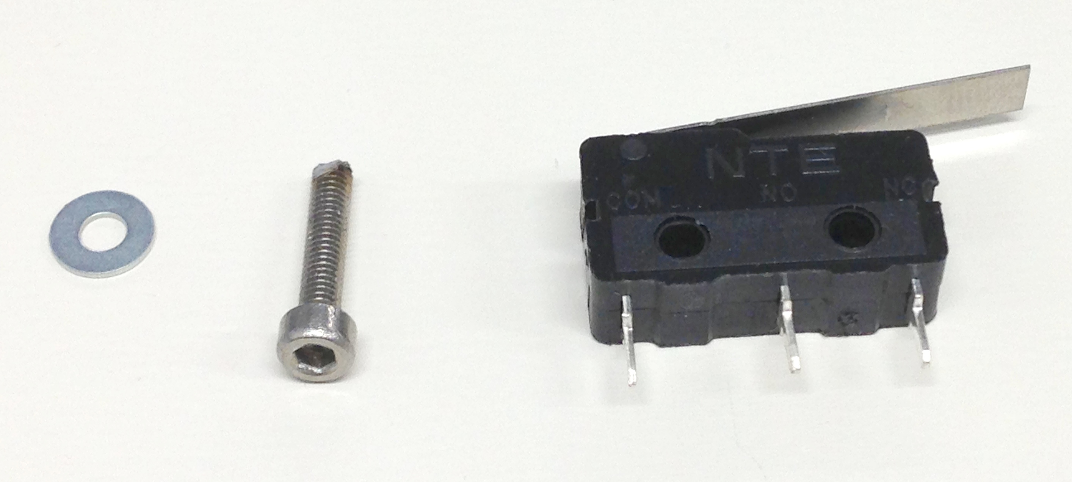
Item | Quantity
Microswtich | 1
M2.5 Washer | 2
M2.5 x 12mm cap screw | 1

Insert the M3 capscrew and washer into the hole fnearest the button of the microswitch with the lever facing upwards. This then screws directly into the small back of the X motor bracket next to the motor as shown below:



